Purpose:
These instructions are for organizations that fall within the North, Toronto, Central, East regions. Note, the West region uses a different intake form to submit requests.
This instruction document is intended to provide Primary Care Providers, Community Health Service Providers, Community-based Physician Specialists and Indigenous Communities and Providers with guidance on how to submit a request for PPE (using the Remedy Intake Form). As part of the transitional support, the following types of PPE can be requested:
- Surgical Masks
- Gloves
- Gowns
- Hand Sanitizer
- Eye protection (face shields and goggles)
- Disinfectant Wipes
If a different PPE category is required (i.e. N95 masks for planned or anticipated Aerosol-Generating Medical Procedures (AGMPs)), please complete a separate Remedy Intake Form as this will be treated as a critical escalation. Note, additional scrutiny and follow-up will be required to understand the rationale for the request.
Important Notes:
- The Remedy Intake Form should be completed as outlined in the instructions below. If the required inputs are not provided, then PPE orders cannot be fulfilled.
- For additional information about the transitional support (including details related to sectors in and out of scope), please refer to the Guidance for Emergency Allocation document.
How-To Instructions:
1. Access the Remedy Intake Form here to submit a PPE request. Note, multiple types of PPE may be requested through one submission of this form.
2. There are five steps as part of the Intake Process: General, Consent, Contact Details, Intake and Confirm.
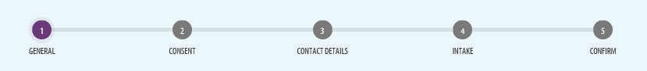
3. Step 1 – General:
- The landing page is typically used as part of the request for critical PPE process. Please refer to the Guidance for Emergency Allocation document as it relates to the principles and expectations as part of the transitional support.
- Select the check-box at the end of the page to proceed to Step 2. Note, the statement is not relevant to the request for transitional support.
- Select ‘Continue’.
4. Step 2 – Consent:
- Read through disclaimer and select the ‘I Consent’ check-box.
- Select ‘Continue’.
5. Step 3 – Contact Details:
- Complete all fields with applicable contact information.
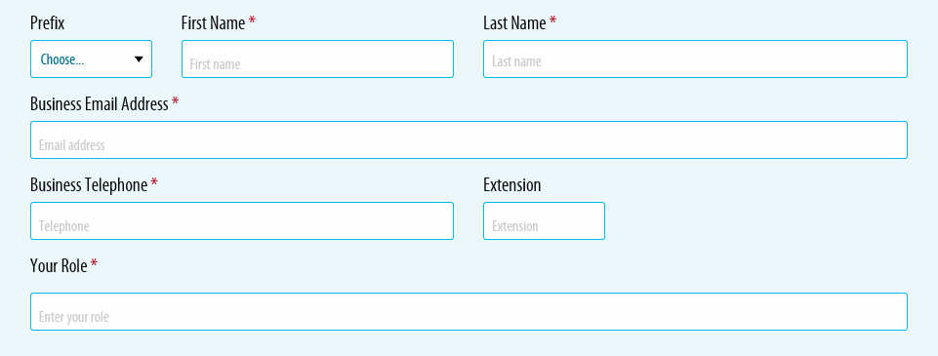
- Select ‘Continue’.
6. Step 4 – Intake:
- Select the region the organization falls into. Use the link provided for guidance on determining the applicable region.
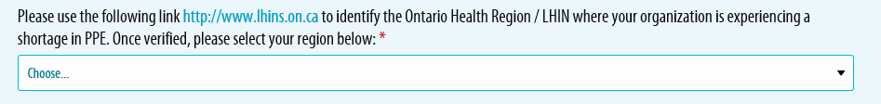
- Select the applicable Organization Type. Please refer to the Guidance for Emergency Allocation document to reference the sectors in-scope as part of the transitional support.
- Enter the Organization Name into the search field (to find your organization, begin by typing the first few letters of your organization’s name). If not available in the list, manually enter the Organization Name or Physician name (if not incorporated) into the second field.
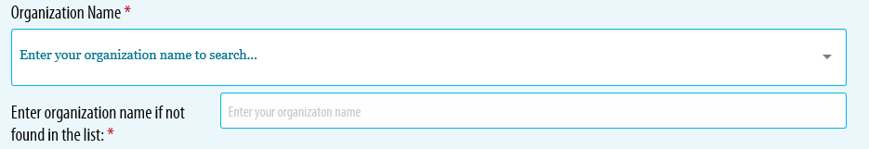
- Select the appropriate response (Yes or No) based on the type of Organization.
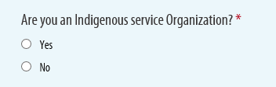
- Select ‘No’ to this question considering the parameters of the transitional support.
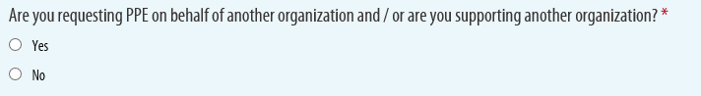
- Enter the Organization Shipping Information. Please make best efforts to provide a business address, and specify preferred shipping days/times and special instructions. If not possible to include a business address, please enter an alternate address and reflect in the ‘Special Instructions’ the type of address.
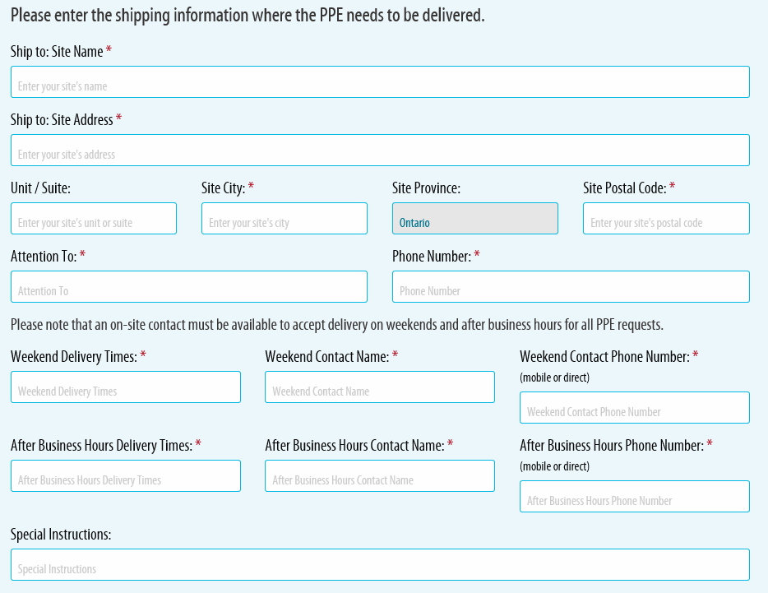
- Select the most appropriate rationale for this request. In most cases, the 3rd option of “Daily Function” will be the best response for your request, however, please select other options that may apply.
Additionally, please include the following statement in the text field to easily identify the nature of this request: “Requesting Pandemic PPE Transitional Support”.
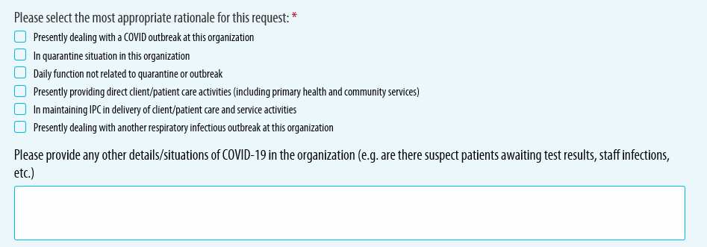
- Select the appropriate response (Yes or No) based on the type of Organization. When considering the vulnerability of the population served, consider the demographic profile as it relates to the epidemiological pattern of disease. Vulnerable patients/populations could include those living in high-risk residential settings including homes serving those with developmental disabilities, shelters for survivors of domestic violence and human trafficking, homeless shelters and children’s residential facilities, etc. Note, selecting “no” to this question, will not impact provision for PPE as part of the transitional support.
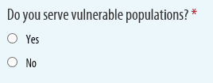
- Select the needed PPE type from the drop-down menu.
Reminder: As part of the transitional support, only the following types of PPE should be requested:
  - Surgical Masks
  - Gloves
  - Gowns
  - Hand Sanitizer
  - Eye protection (face shields and goggles)
  - Disinfectant Wipes
If a different PPE category is required (i.e. N95 masks for planned or anticipated Aerosol-Generating Medical Procedures (AGMPs)), please complete a separate Remedy Intake Form as this will be treated as a critical escalation. Note, additional scrutiny and follow-up will be required to understand the rationale for the request.
- Once the PPE Type is selected, the Description field becomes active. Select the applicable description from the drop down menu. Note, the drop-down menu options change depending on the PPE Type selected in the previous field.
- This field is not applicable to the parameters of the transitional support, but since it is a mandatory field, please enter the estimated quantity needed for the organization. A value other than zero must be entered. (Note, step ‘x’ below requests the entry of specific inputs which will be used to support the estimation of allocation quantities i.e. number of patient-facing clinical and non-clinical staff and learners in the practice/organization and number of Clients/Patients the practice/organization services.
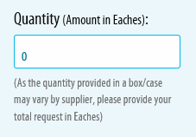
- This field is not applicable to the parameters of the transitional support, but since it is a mandatory field, please select ‘7 days’ from the drop-down menu. Note, as part of the transitional support, allocations will be provided for a time limited period and will be consistently applied across all regions based on the methodology provided.
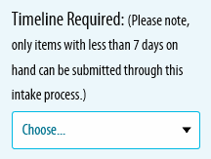
- If ‘gowns’ is the selected option from the PPE Type/Description fields, than a conditional question will appear. Select the appropriate response (Yes or No) based on preference.
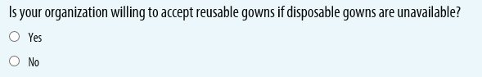
- If ‘hand sanitizer’ is the selected option from the PPE Type/Description fields, than a conditional question will appear. Select the appropriate response (Yes or No) based on preference.
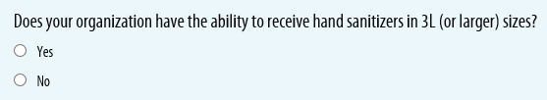
- Enter on-hand inventory quantity, if applicable. If not, zero is an appropriate response.
- Enter estimated average consumption and/or follow guidance provided (i.e. if you have not used this item before or do not know the consumption rate, please indicate how much of this items you expect to use each day or provide best estimate).
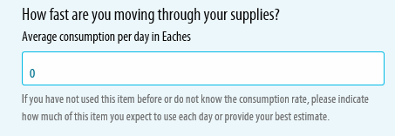
- This field is not applicable to the parameters of the transitional support. A value of “0” is accepted for this field.
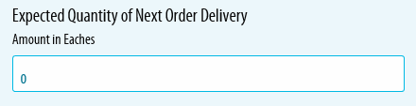
- This field is not applicable to the parameters of the transitional support. This field can remain blank.
- Select the appropriate response (Yes or No), if applicable. If ‘No’ is selected, please enter “Requesting Pandemic PPE Transitional Support” into the ‘Please provide details’ field. If ‘Yes’ is selected, please enter details as to the order status in the ‘Please provide details’ field.
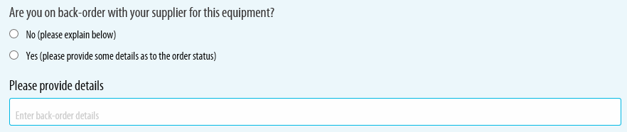
- Select the appropriate response (Donated or No) based on the Organization’s preference. Note, the questions and options will change depending on the PPE Type requested (e.g., if gowns are selected, the check boxes will display as aged, donated, expired, and no).
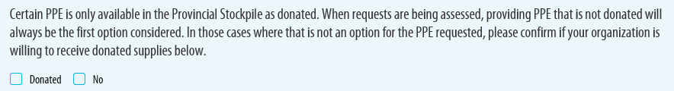
- Select the ‘Add’ button. You must click the ‘Add’ button for the PPE item to be added to the request. Do not proceed to the next page without clicking ‘Add’ after each PPE request entry.
If you need to request multiple PPE items you may do so by choosing another PPE item from the dropdown menu.
- This field is not applicable to the parameters of the transitional support. A response of ‘No’ is acceptable.
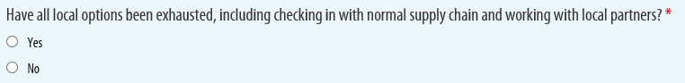
- Select the appropriate response (Yes or No) based on processes implemented by the Organization. If ‘Yes’ is selected, please summarize activities in the comments field.
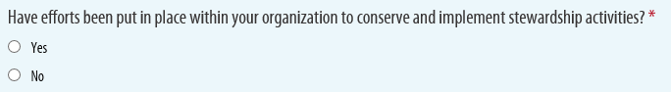
- Enter into this field the inputs required to support the estimation of allocation quantities. This includes: 1. the number of patient-facing clinical staff and learners in the practice/organization, 2. the number of non-clinical staff in the practice/organization, and 3. the number of Clients/Patients the practice/organization services.

- Select ‘Continue’.
7. Step 5 – Confirm:
- Review request and ensure all requested PPE items are listed.
- Select ‘Submit’.

