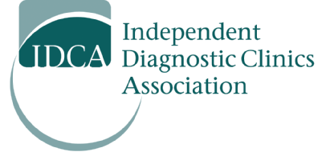

**ATTEND AND LEND YOUR VOICES!**

**September 20th -- Learn where IHFs fit into the new healthcare structure!**

The government is introducing sweeping changes to the delivery of healthcare in Ontario. This is a transformative time in which significant policy initiatives are being both considered and implemented. It is up to the IHF sector to demonstrate that it will remain a vital contributor to the integrated healthcare systems that are being proposed.

The decision-makers and policy developers from the newly formed Ontario Health will be present and will provide information regarding a multitude of regulatory issues. These will include the composition of Ontario Health Teams, initiatives by the IHF Program, the new directions and re-focused initiatives of Cancer Care Ontario, eHealth and Health Quality Ontario, and the refined roles of Public Health Ontario and the College of Physicians and Surgeons (Ontario). **They plan to share information and are seeking your feedback directly.**

In addition to speakers addressing regulatory issues, the conference will also feature speakers addressing operational matters that are of great interest to IHF owners, both large and small.

Let us ensure that those influencing the redesign of our healthcare system know that our industry already reflects the government’s goal of ensuring “the right care, at the right time and in the right setting.” Our sector already provides nearly 10 million outpatient diagnostic services annually in Ontario, which represents roughly 50% of all such diagnostic procedures performed.

**On Friday September 20, 2019, please make sure to attend the IDCA conference at Le Parc Conference Centre in Richmond Hill. As an IHF owner, if you cannot attend, ensure that a representative from your organization is present to listen, learn and share. Attached is your registration form.**

**Register and attend on September 20th!**

Sincerely,



Gerald Hartman – President

Independent Diagnostic Clinics Association